**Daily Scrum or Standup Meeting**

Team name: 5th Element

Scrum Master: Leonardo Craven

Date: October 26, 2021

| **Team Member** | **What did you do since the last scrum?** | **What do you plan to do before the next scrum?** | **What obstacles do you have?** |
| --- | --- | --- | --- |
| Leo | Nothing | Add CSS to previously worked pages | None |
| Gavin | Completed sponsor request management page | Add CSS to previously worked pages, add capability for managers to delete tournaments from tournament signup page | None |
| Andrew (not present at meeting) |  |  |  |
| Brock | Nothing | Add CSS to previously worked pages | None |

# Burndown

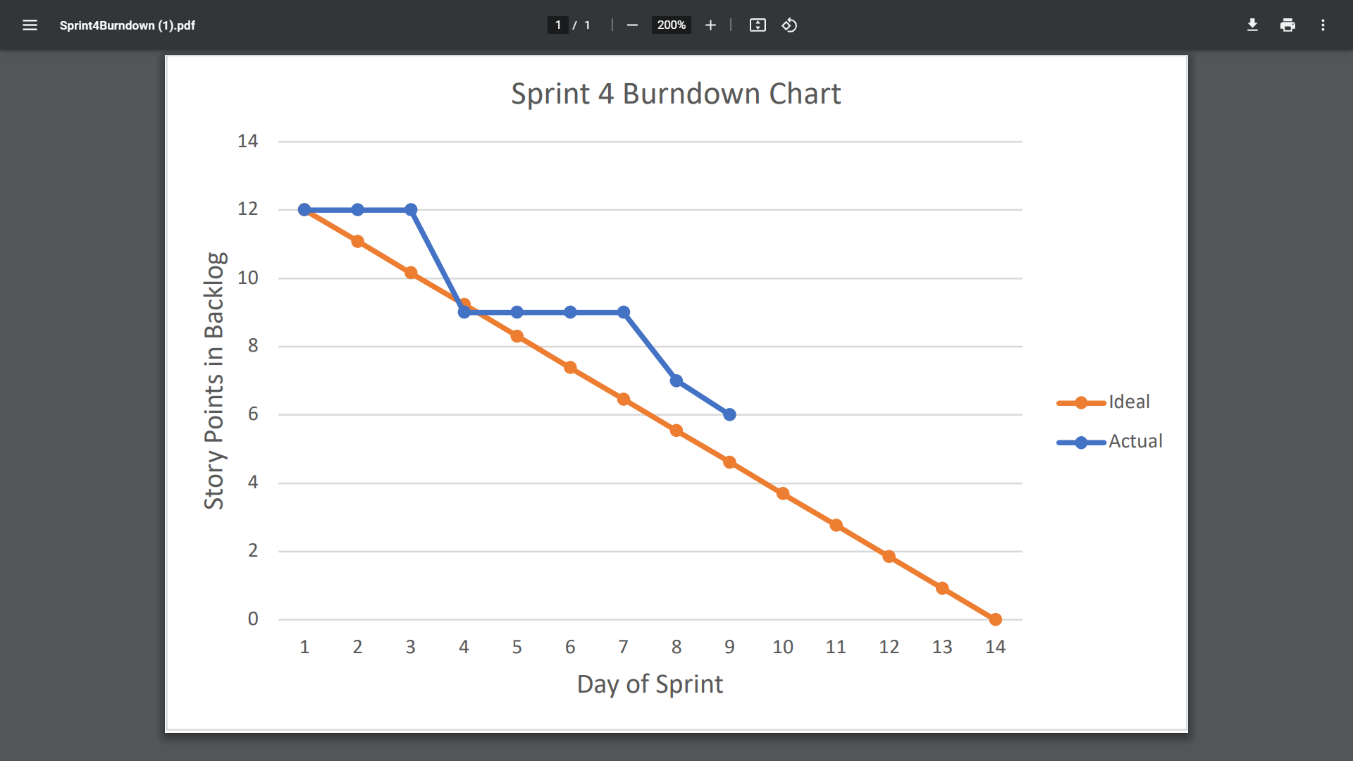

# Screenshot of you project board

